**Muscles of Head**

**The muscles of facial expression**

**Contents**

* [1 Orbital Group](http://teachmeanatomy.info/head/muscles/facial-expression/#Orbital_Group)
* [2 Nasal Group](http://teachmeanatomy.info/head/muscles/facial-expression/#Nasal_Group)
* [3 Oral Group](http://teachmeanatomy.info/head/muscles/facial-expression/#Oral_Group)

The muscles of facial expression are located in the**subcutaneous tissue**, originating from bone or fascia, and inserting onto the skin. By contracting, the muscles pull on the skin and exert their effects. They are the only group of muscles that insert into skin.

These muscles have a common embryonic origin – the 2nd **pharyngeal arch**. They migrate from the arch, taking their nerve supply with them.  As such, all the muscles of facial expression innervated by the **facial nerve**.

The facial muscles can broadly be split into three groups; **orbital**, **nasal** and **oral**.

**Orbital Group**

The orbital group of facial muscles contains two muscles associated with the **eye socket**. These muscles control the movements of the **eyelids**, important in protecting the **cornea** from damage. They both innervated by the **facial nerve.**

**Orbicularis Oculi**

The **orbicularis oculi** muscle surrounds the eye socket and extends into the eyelid. It has three distinct parts – palpebral, lacrimal and orbital.

* **Attachments**– Originates from the medial orbital margin, the medial palpebral ligament, and the lacrimal bone. It then inserts into the skin around the margin of the orbit, and the superior and inferior tarsal plates.
* **Actions:**
  + Palpebral part – gently closes the eyelids.
  + Lacrimal part – involved in the drainage of tears.
  + Orbital part – tightly closes the eyelids.
* **Innervation** –[Facial nerve](http://teachmeanatomy.info/head/cranial-nerves/facial-nerve/) (CN VII, temporal and zygomatic branches)

**Corrugator Supercilii**

The corrugator supercilii is a much smaller muscle, and is located**posteriorly** to the orbicularis oculi muscle.

* **Attachments**– Originates from the superciliary arch, running in a superolateral direction. Inserts into the skin of the eyebrow.
* **Actions**– Acts to draw the eyebrows together, creating vertical wrinkles on the bridge of the nose.
* **Innervation** – Facial nerve.

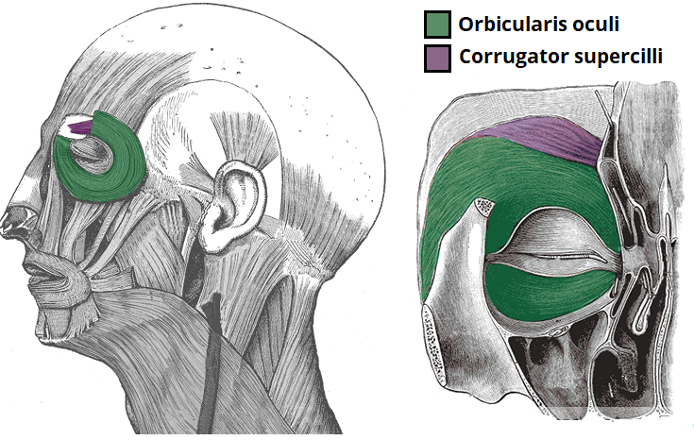

Fig 1 – The two orbital muscles of facial expression.

**Nasal Group**

The nasal group of facial muscles are associated with movements of the **nose**, and the skin around it. There are three muscles in this group, and they all innervated by the **facial nerve**. They serve little importance in humans.

**Nasalis**

The nasalis is the **largest** of the nasal muscles. It is split into two parts; transverse and alar.

* **Attachments:** Both portions of the muscle originate from the maxilla.The transverse part attaches to an aponeurosis across the dorsum of the nose. The alar portion of the muscle attaches to the alar cartilage of the [nasal skeleton](http://teachmeanatomy.info/head/osteology/nasal-skeleton/).
* **Actions:**The two parts have opposing functions. The transverse part compresses the nares, and the alar part opens the nares.
* **Innervation:**Facial nerve.

**Procerus**

The procerus is the most **superior** of the nasal muscles. It also lies **superficially** to the other muscles of facial expression.

* **Attachments:** It originates from the nasal bone, inserting into the lower medial forehead.
* **Actions:**  Contraction of this muscle pulls the eyebrows downward to produce transverse wrinkles over the nose.
* **Innervation:**Facial nerve.

**Depressor Septi Nasi**

This muscle assists the alar part of the nasali in opening the nostrils.

* **Attachments:** It runs from the maxilla (above the medial incisor tooth) to the nasal septum.
* **Actions:**It pulls the nose inferiorly, opening the nares.
* **Innervation:**Facial nerve.

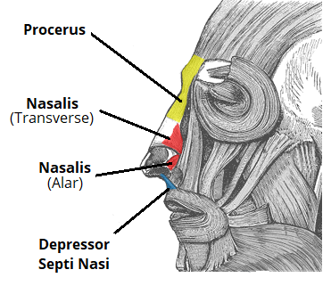

Fig 2 – The nasal muscles of facial expression. Note the nasalis muscle is comprised of two parts.

**Oral Group**

These are the most important group of the facial expressors, responsible for movements of the **mouth** and **lips**. Such movements are required in singing and whistling, and add emphasis to vocal communication. The oral group of muscles consists of the orbicularis oris, buccinator, and various smaller muscles.

**Orbicularis Oris**

The fibers of the orbicularis oris enclose the opening to the oral cavity.

* **Attachments:**Arises from the maxilla and from the other muscles of the cheek. It inserts into the skin and mucous membranes of the lips.
* **Action:**Purses the lips.
* **Innervation:**Facial nerve.

**Buccinator**

This muscle is located between the mandible and maxilla, deep to the other muscles of the face.

* **Attachments**: It originates from the maxilla and mandible.  The fibers run in an inferomedial direction, blending with the orbicularis oris and the skin of the lips.
* **Actions**: The buccinator pulls the cheek inwards against the teeth, preventing accumulation of food in that area.
* **Innervation**: Facial nerve.

**Other Oral Muscles**

Other muscles act of the lips and mouth. Anatomically, they can divided into upper and lower groups:

* The**lower group**contains the depressor anguli oris, depressor labii inferioris and the mentalis.
* The **upper group** contains the risorius, zygomaticus major, zygomaticus minor, levator labii superioris, levator labii superioris alaeque nasi and levator anguli oris.

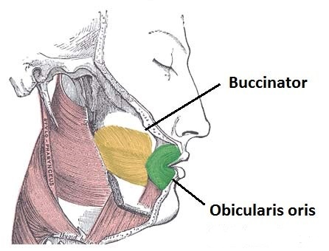

Fig 3 – The main oral muscles of facial expression. Note how the fibers of buccinator and obicularis oris blends together

**The end**